

Software Engineering Department
Braude College of Engineering

Capstone Project - Phase B (61999)

Code Escape Together

26-1-D-16

Students:
Daniel Rozentsvaig - Daniel.Rozentsvaig@e.braude.ac.il
Elias Farah - Elias.Farah@e.braude.ac.il

Advisor: Dr. Sulamy Moshe - MosheSu@braude.ac.il

GitHub Repository: https://github.com/Luffyyy/Capstone-Project
Table of Contents
Abstract 3
1. Introduction 3
2. Related Work 4
3. Project Review and Process Description 5
3.1. General Description 5
3.2. Solution Description 6
3.3. Diagrams 7
3.3.1. Activity Diagram 7
3.3.2. Package Diagram 7
3.4. Scenes and Levels 8
3.5. Functional Requirements 13
3.6. Acceptance Test 13
3.7. Challenges and Solutions 14
3.7.1. Development Process 14
3.7.2. Development Tools 15
3.8. Challenges 15
3.8.1. Multiplayer Synchronization 15
3.8.2. Puzzle Design 15
3.8.3. Network Architecture 16
3.8.4. Performance and Assets 16
3.8.5. User Experience 16
3.9. Results and Conclusion 17
3.10. Lessons Learned 17
3.11. Meeting the Project Goals 18
4. User Manual 19
4.1. Requirements 19
4.1.1. PC System Requirements (Server Side) 19
4.1.2. Mobile System Requirements (Client Side) 19
4.2. Installation 19
4.2.1. PC Installation 19
4.2.2. Mobile Installation 19
4.3 Hosting and Joining a Server 20
4.4 Game Controls 21
4.5 Gameplay elements 22
5. Maintenance Guide 25
5.1. Installing Unity Hub 25
5.2. Downloading and Importing the Project 25
5.3. Structure Walkthrough 26
5.4. Running in Editor 28
5.5. Building 28
5.6. Notes 28
6. References 29

Abstract
Programming may be a difficult subject to grasp at first, especially for teenagers when it’s introduced through abstract or text-heavy methods.
Traditional methods often fail to provide an engaging, collaborative environment where students can actively apply computational thinking. There is a lack of accessible programs that demonstrate real-time interaction between different components in a system.
Code Escape Together addresses these issues by creating a multi-device, cooperative escape-room game that teaches programming logic through visual, interactive tasks with the interaction being done via peer-to-peer connection between clients.

Introduction
Code Escape Together is a 3D cooperative (Co-op) escape room game for two players that teaches the fundamentals of programming and algorithms through immersive and collaborative gameplay that requires both players to construct code using elementary building blocks to overcome in-game challenges.
The primary audience for the project is teenagers and beginner programmers who often find traditional, text-heavy programming courses too daunting and overwhelming.
To ensure maximum accessibility, comfort and appeal, the method of “coding” utilizes placing logical visual programming blocks, allowing the player to focus on the code’s meaning rather than syntax.
In Code Escape Together, the players must escape a room using coding logic to solve puzzles. As the game progresses, it introduces new programming concepts that players must use to escape. It also requires the two players to work together to escape the room, in true cooperative fashion.
Code Escape Together uses peer-to-peer (P2P) technology for the players to communicate with each other. It features a main screen which acts as the host machine displaying the game and two smartphones which are connected and act as controllers for the players.
By combining visual programming, escape rooms, and cooperative gameplay, Code Escape Together aims to provide an innovative educational experience that bridges the gap between theoretical learning and practical learning.

Related Work
In recent years, with the rise of AI tools, teenagers are becoming less interested in reading and exploring topics independently. They rely on AI tools to do their job for them; this is becoming an issue that may cause teenagers to not think for themselves and may reduce their ability to solve analytical problems. Moreover, traditional methods like books and presentations often fail to hold the students’ concentration, resulting in disinterest during lectures.
To combat these issues, schools and academies are shifting toward collaborative learning environments, such as coding laboratories and group projects that force students to work together. Educators are also turning to Game-Based Learning (GBL) to address low attention spans. Research highlights the effectiveness of gamification elements like leaderboards and badges [‎1], storytelling [‎2], and educational escape rooms [‎3] in boosting engagement. Visual, block-based programming environments support this shift by replacing text-heavy syntax with intuitive blocks, allowing learners to focus purely on core logic, sequencing, and problem-solving while promoting teamwork and active participation [‎4].
Several research-backed educational tools have been studied to address these challenges:
[‎5] showcases a randomized controlled trial involving 326 software engineering students comparing a virtual escape room to traditional lectures. The study found that students in the escape room group demonstrated significantly better knowledge acquisition and expressed highly positive perceptions of the activity. The authors emphasize the need for further strong empirical evidence.
Scottie Go! [6] is an active learning tool that uses an interactive, puzzle-based mobile game where students must physically arrange cardboard coding tiles to write commands, which they then scan with a companion app to execute. To maintain high engagement, the game features a narrative where players help an alien named Scottie repair his spaceship, and it rewards players with stars based on how efficiently they optimize their code.
Escape with Python [‎7], designed for K-12 students and informal learning spaces, is a web-based, retro-styled RPG escape room that consists of 10 rooms covering variables, sequences, conditions, iterations, and functions. While 12 testing teachers praised its ability to explain abstract logic visually, they noted that the game lacked clear control instructions and featured a steep difficulty curve that jumped too quickly between challenges.
Online Robot City [‎8] presents a multiplayer game that is a digital adaptation of a board game designed to teach computational thinking to primary school students. Operating on a 2D grid, teams of at least four players must use movement and conditional cards to command robots to collect resources. A study of 12 elementary school students showed that the game improved results in both learning outcomes and user engagement. It had a positive effect on students’ test scores. Out of the participating teams, four improved their scores, one remained the same and one decreased slightly.
Aside from academic solutions, there are commercial cooperative escape room games, one example is Escape Simulator [‎9], it is a first person escape room game developed by Pine Studio and released in 2021. The player must figure out how to escape the room by solving puzzles. It can be played cooperatively with up to 10 players.
The solutions seem promising, but they usually focus on groups of students or a single student. Some don’t use visual programming, which is where Code Escape Together fills the gap, since Code Escape Together requires two players to work together, coordination is more important.

Project Review and Process Description

General Description
The primary goal of the system is to increase student engagement and improve understanding of fundamental programming concepts, including algorithms, logic, and problem solving. These goals are achieved by presenting players with a sequence of escape room challenges that require collaboration, communication, and the application of programming knowledge to progress through the game.
The system was developed using the Unity game engine and the Mirror networking framework, enabling the two players to connect to the same game session and cooperate in real time. The game consists of several themed levels, each containing unique programming puzzles, interactive objects, and collectible lore items. Built-in journal records collected items throughout the game, encouraging exploration while providing additional story elements.
The target audience includes teenagers, beginner programmers, and anyone interested in learning programming fundamentals in a more interactive and enjoyable way. The game can be used as a supplementary educational tool in academic courses or as a standalone learning experience for two individuals who prefer game-based learning.

Solution Description
The system follows a client-server architecture and was developed using the Unity game engine and the Mirror networking framework.
The application consists of several main components:
- Networking – Handles player connections, synchronization of game objects, and communication between clients and the server using the Mirror networking library.
- Level Components – Controls various parts of the level such as start positions, camera and portal to the next level.
- Entities – Contains the logic of various entities found in a level such as doors, keypads, hints and collectibles.
- User Interface (UI) – Provides menus, interaction windows, puzzle interfaces, notifications, and a journal that records collected lore items.
- Player Logic – Provides controls for the player and customization options.
- VPL – In charge of reading, displaying and executing the visual programming language.
The system is organized into multiple Unity scenes, with each level containing its own environment, puzzles, and objectives. Mirror synchronizes player positions, object states, and puzzle progress so that all participants share the same game world in real time.
The overall architecture separates networking, gameplay logic and user interface into independent components. This modular design improves maintainability, simplifies testing, and makes it easier to extend the game by adding new puzzles, levels, or gameplay mechanics.

Diagrams

Activity Diagram
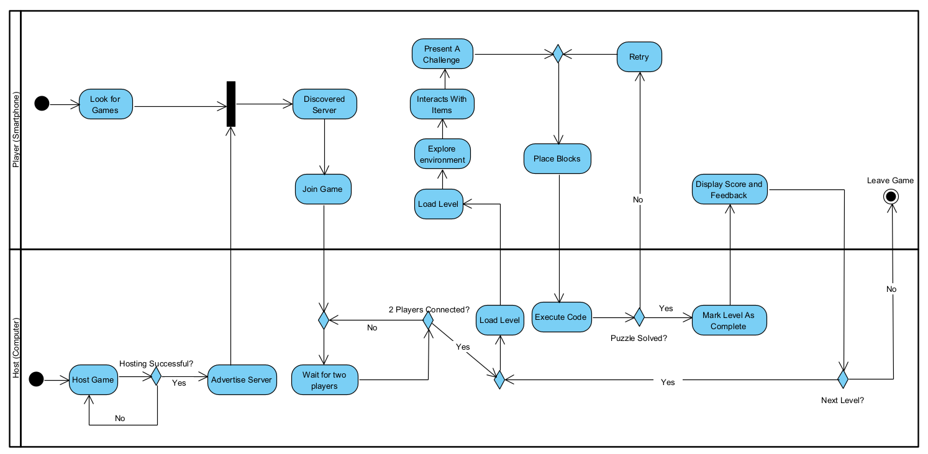
The activity diagram illustrates the overall workflow of the game; from the moment players start a multiplayer session until they complete the final level. It describes the sequence of actions performed by both the players and the system, including joining a game, progressing through levels, solving cooperative puzzles, interacting with items and completing the escape room. The diagram provides a clear overview of the game's logic and demonstrates how player actions drive progression throughout the entire gameplay experience.

Package Diagram
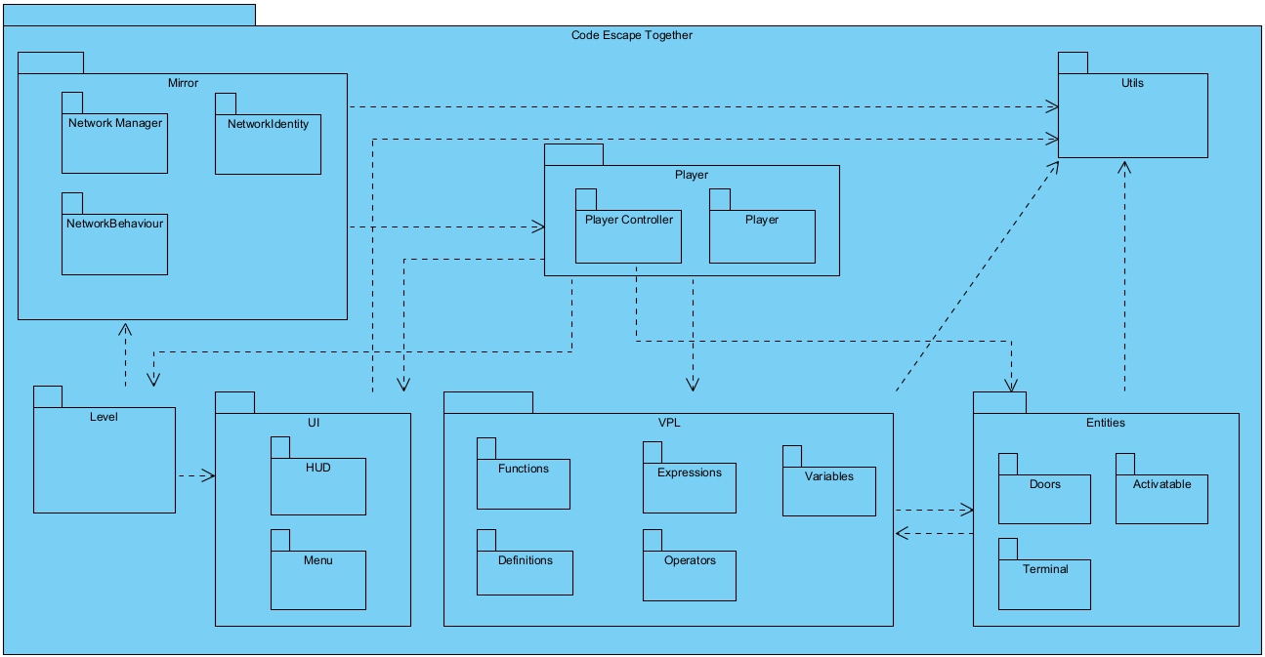
The package diagram presents the high-level architecture of the system by grouping related components into logical modules and illustrating the dependencies between them. It provides an overview of how the different parts of the application, such as networking, gameplay, user interface, and game management, interact to form the complete system.

Scenes and Levels
The game consists of four unique levels, each designed with a distinct look, gameplay mechanics, and programming-related challenges. The levels gradually increase in difficulty while encouraging cooperation between players. Every level introduces new puzzles that require communication, logical thinking, and teamwork to progress.
Level 1
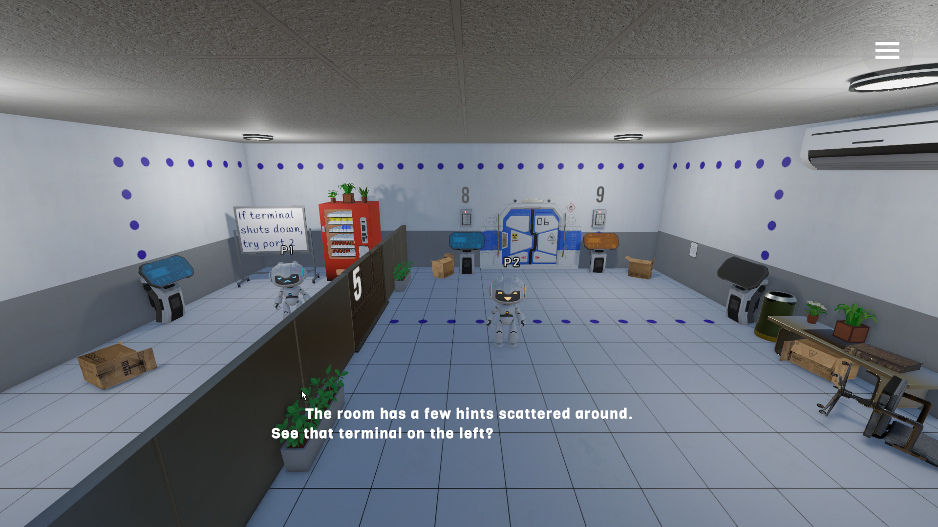
The first level introduces the players to the game's mechanics. Including movement, interaction, VPL blocks and cooperative puzzle solving. It serves as a tutorial while familiarizing players with the escape room environment.
The level also features a narrator helping the players on their first level which reacts to the player’s actions. For example, interacting with the left terminal will prompt the narrator to explain about the terminals.
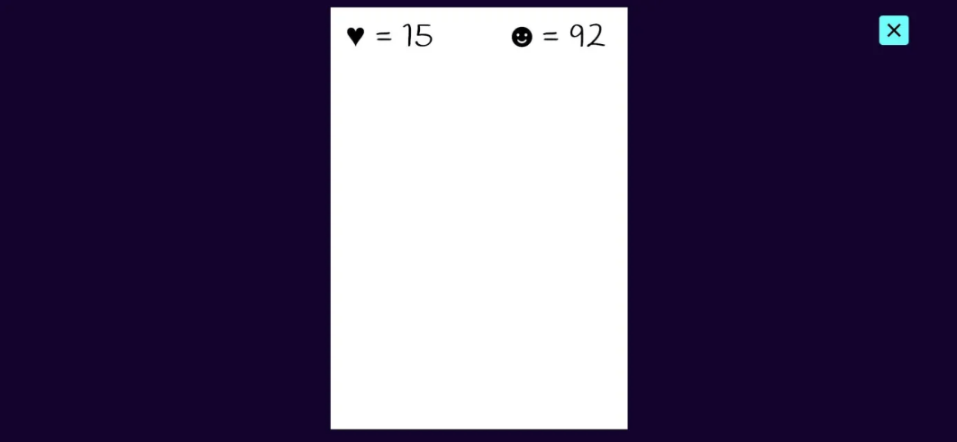
The level features two interactable hints which the players need to find to figure the passwords for the keypads on the doors. Once they figure it out, the door will open, allowing them to escape the room.
Level 2
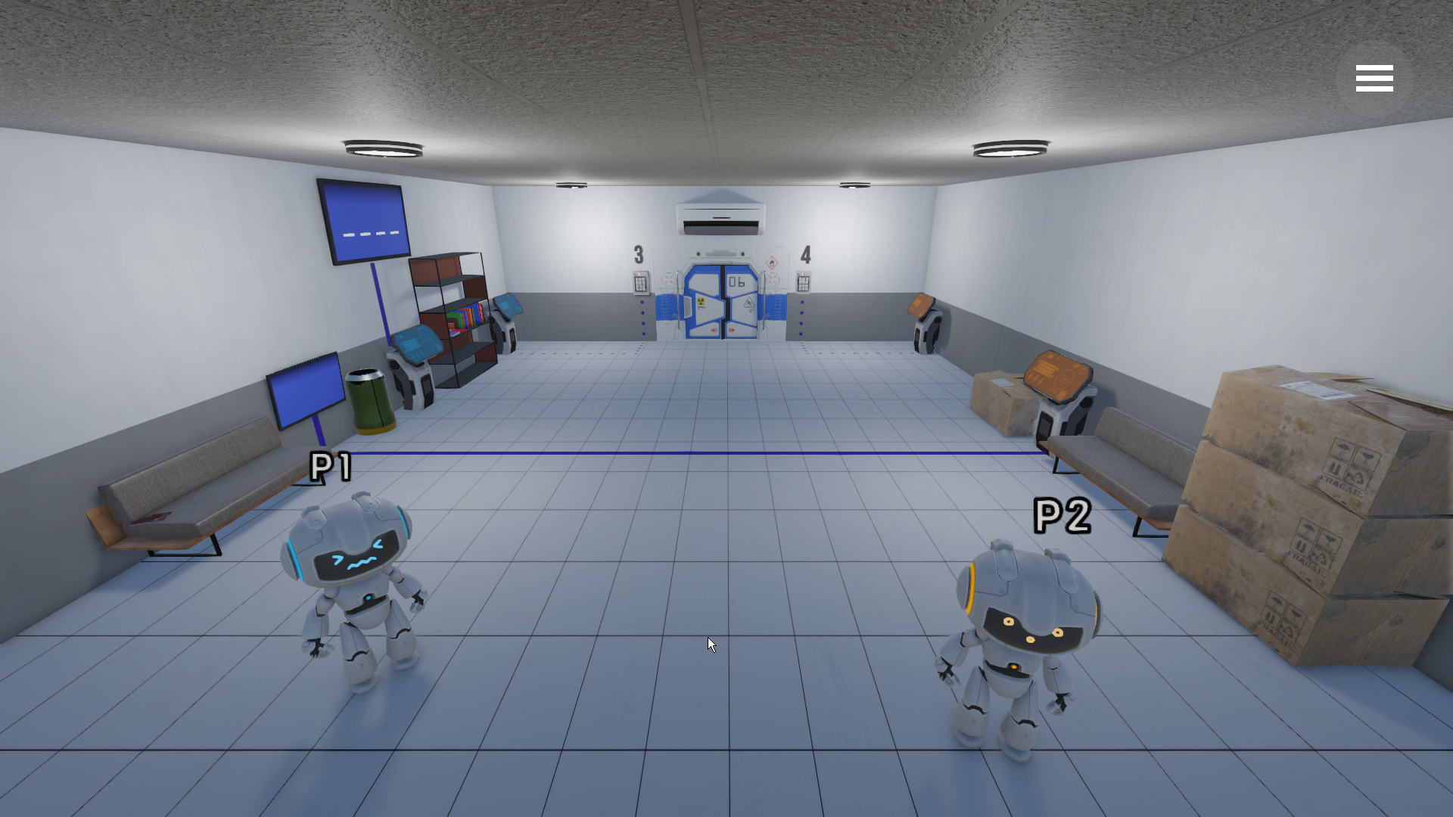
The second level presents more complex programming-based puzzles, on the right the players must work together to solve a maze. Meanwhile on the left, the players need to find hints about the cipher and key so they can decipher it.
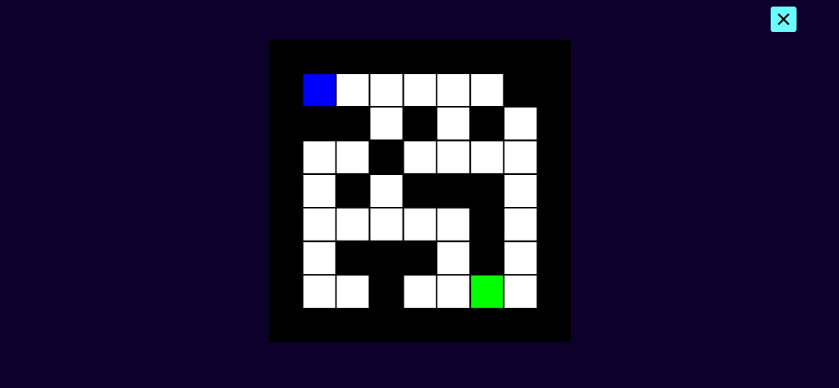
After solving the first puzzle, the room opens a hidden door that contains a hint. Together with that hint and another hint hidden in the room, the players can solve the second puzzle. After that puzzle, another hidden door will open, revealing the last hint which is used to open the door.
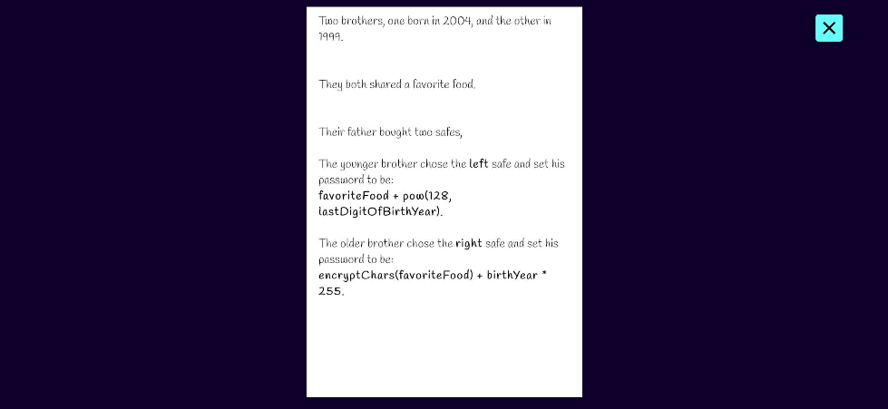
Level 3
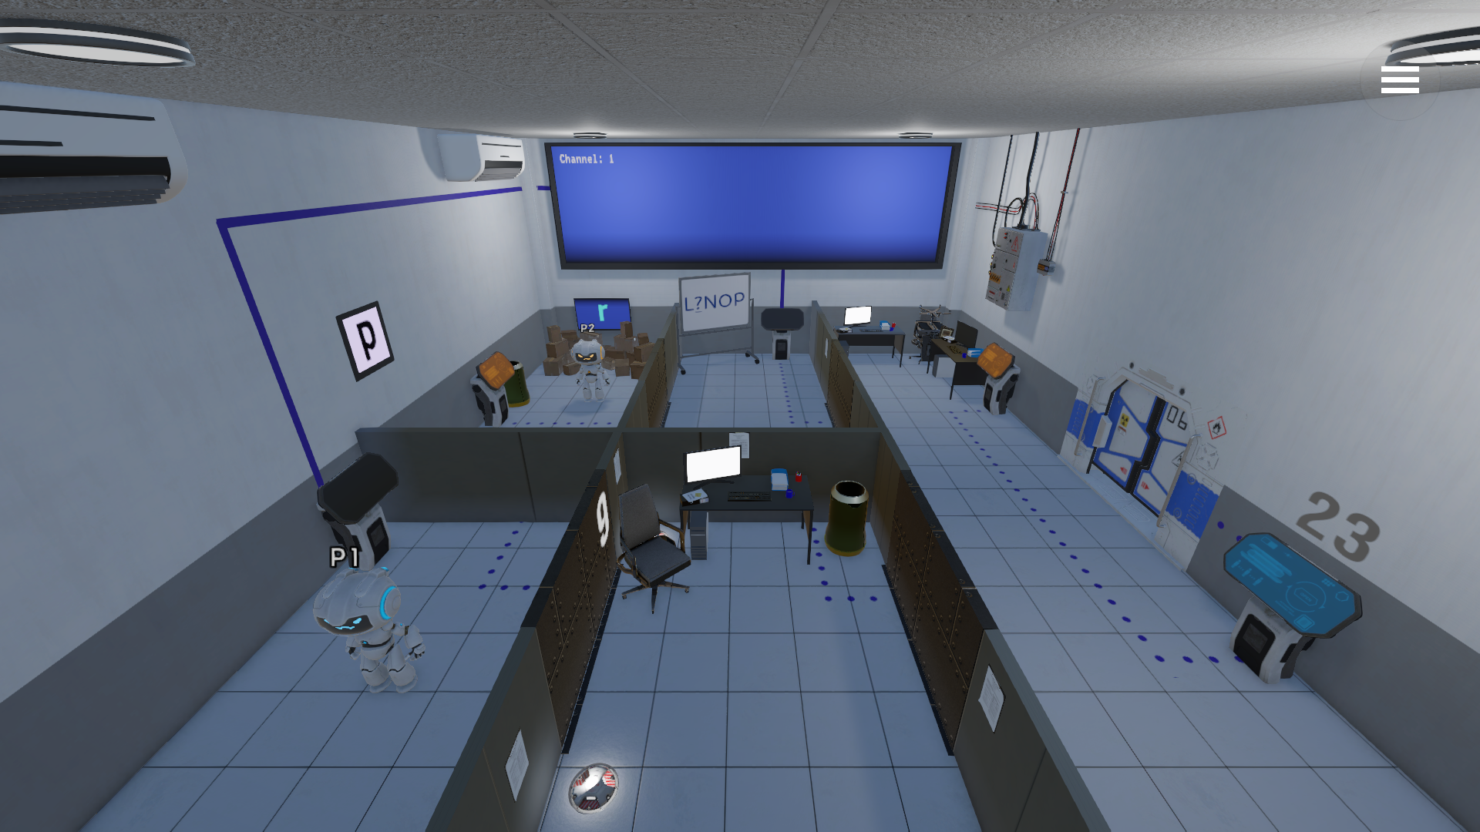
This level focuses on puzzles that require communication between players. The challenges become more difficult and emphasize teamwork. With the first puzzle being a fun hangman game, but first the players must open the doors for hints about the channel of the TV, which currently does not display the hangman game.
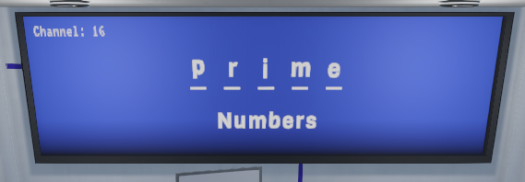
After figuring out the channel number the players collect enough hints to figure out the hidden word on the screen. With that word, they can proceed to the last puzzle which is all about prime numbers!
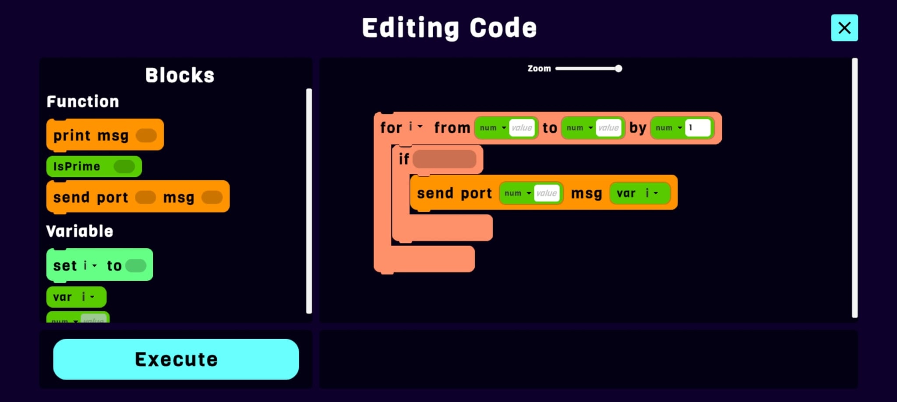
With a hint they find, one player sends a stream of prime numbers to the other player’s terminal.
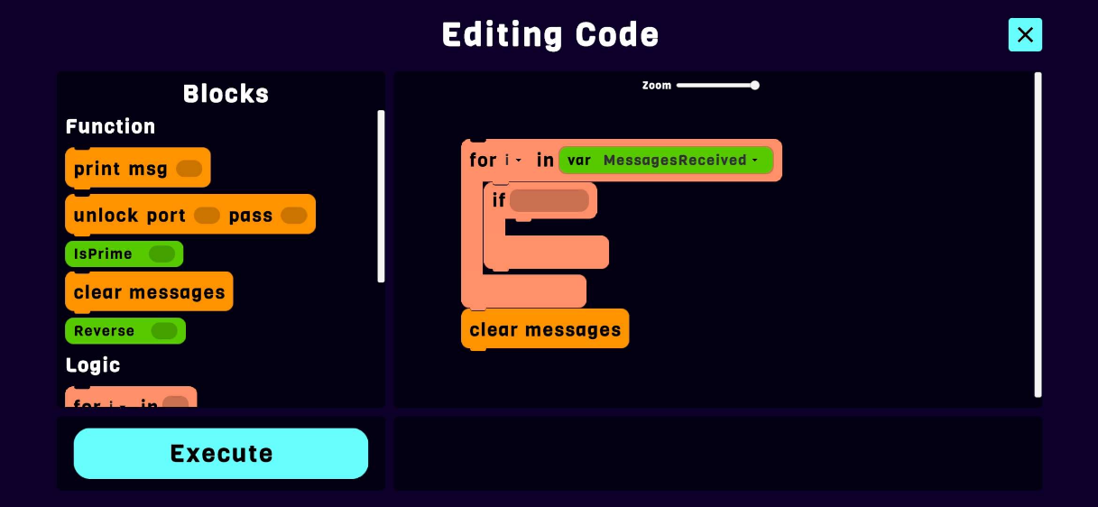
The other player then can go over these numbers and using the hint, unlock the final door.
Level 4
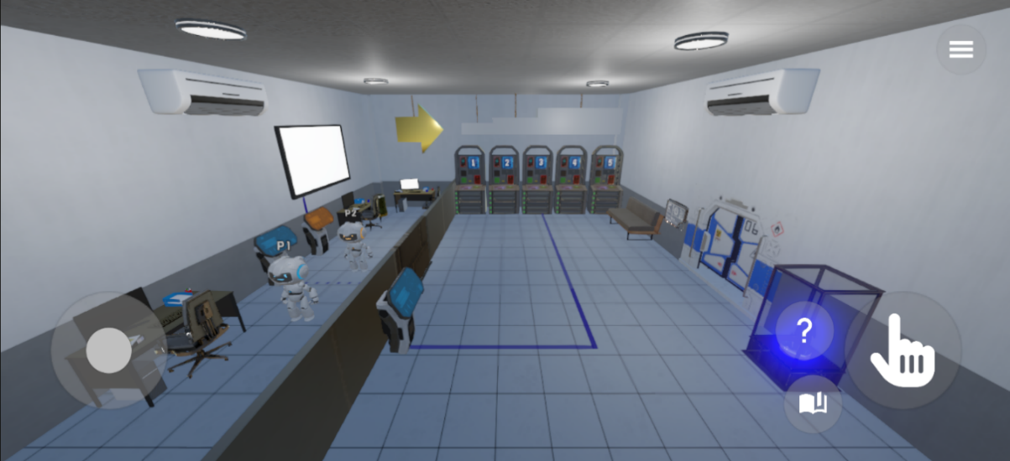
The final level combines multiple mechanics introduced throughout the game into a fun cooperative challenge.
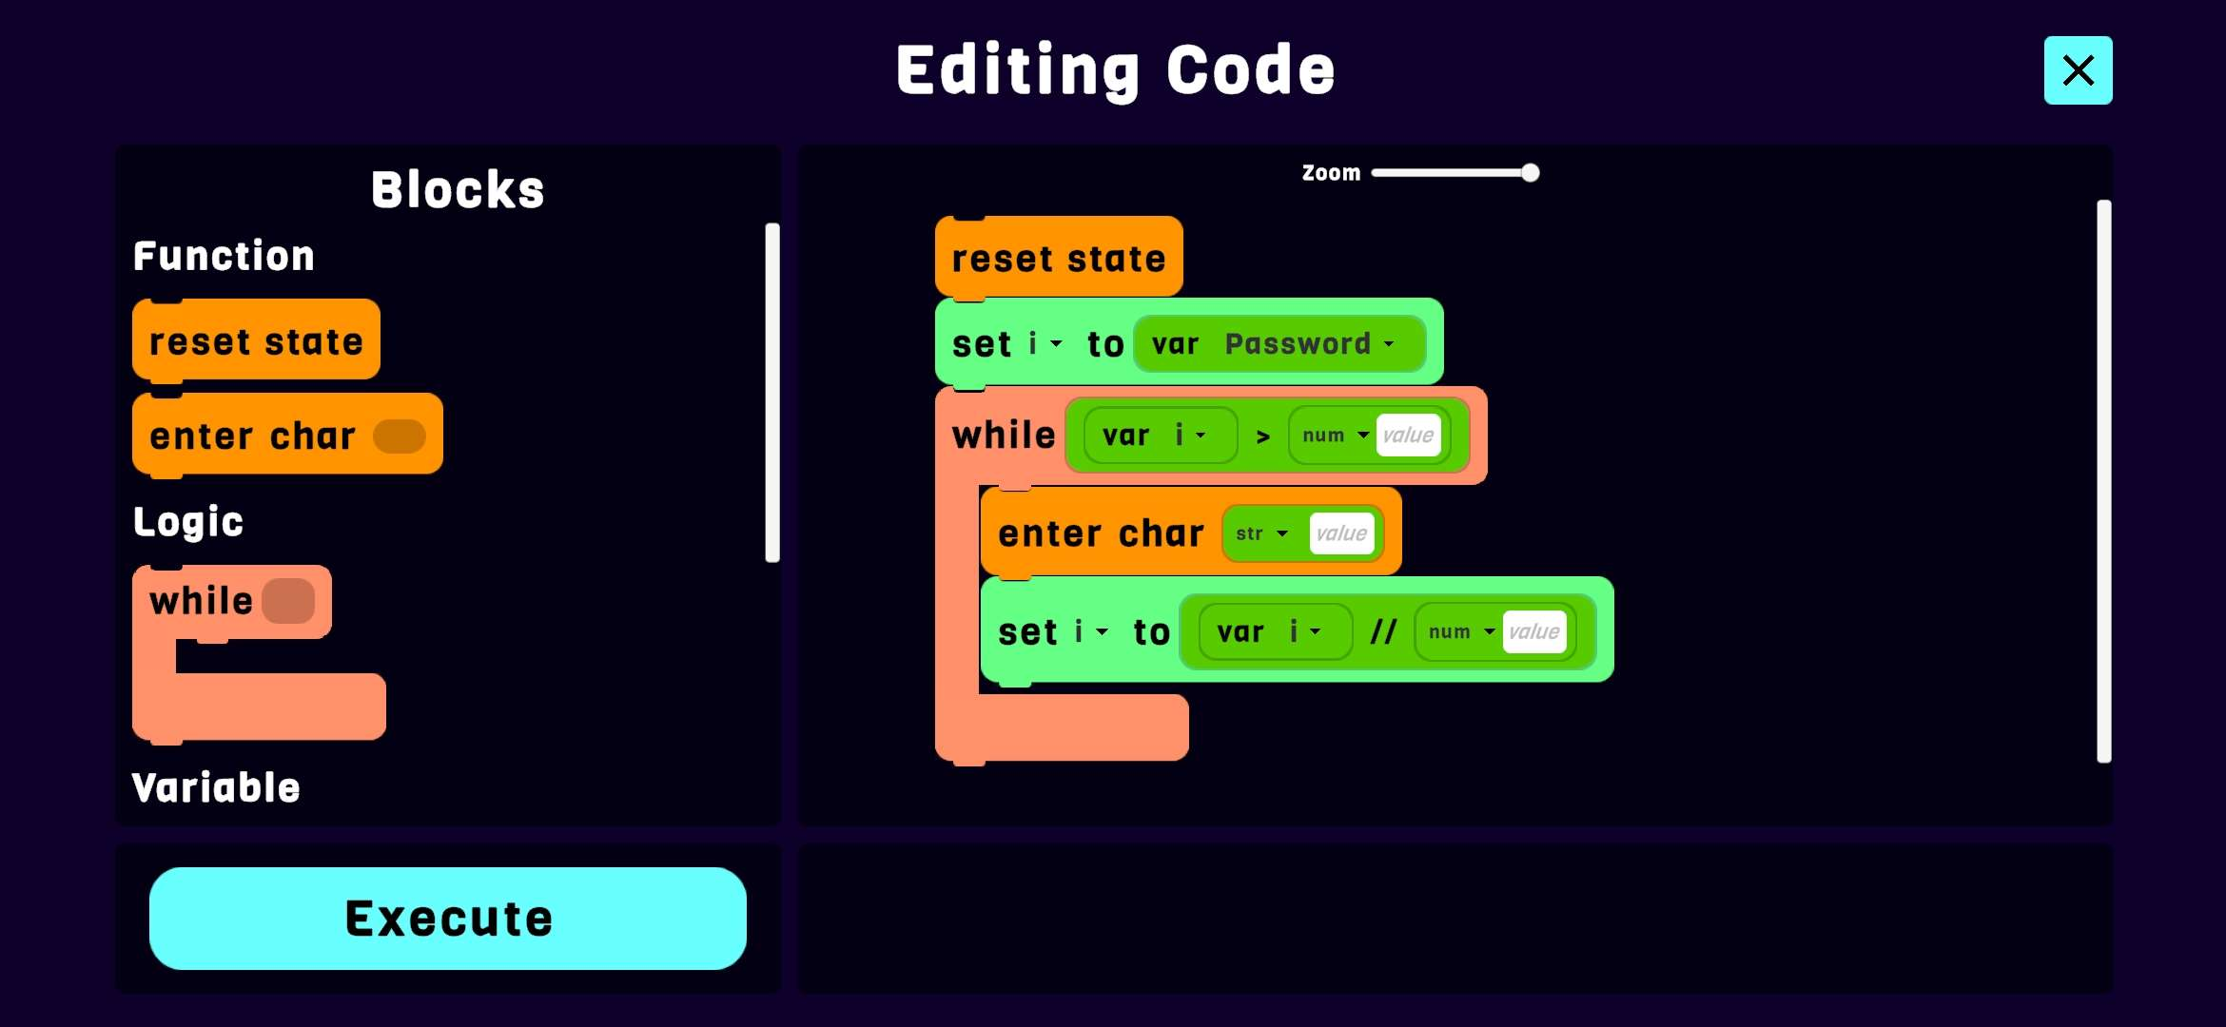
The first puzzle is about teaching the players how you can use a while loop to split a number into digits. The entered characters will show on the screen which is used as the password for the first door.
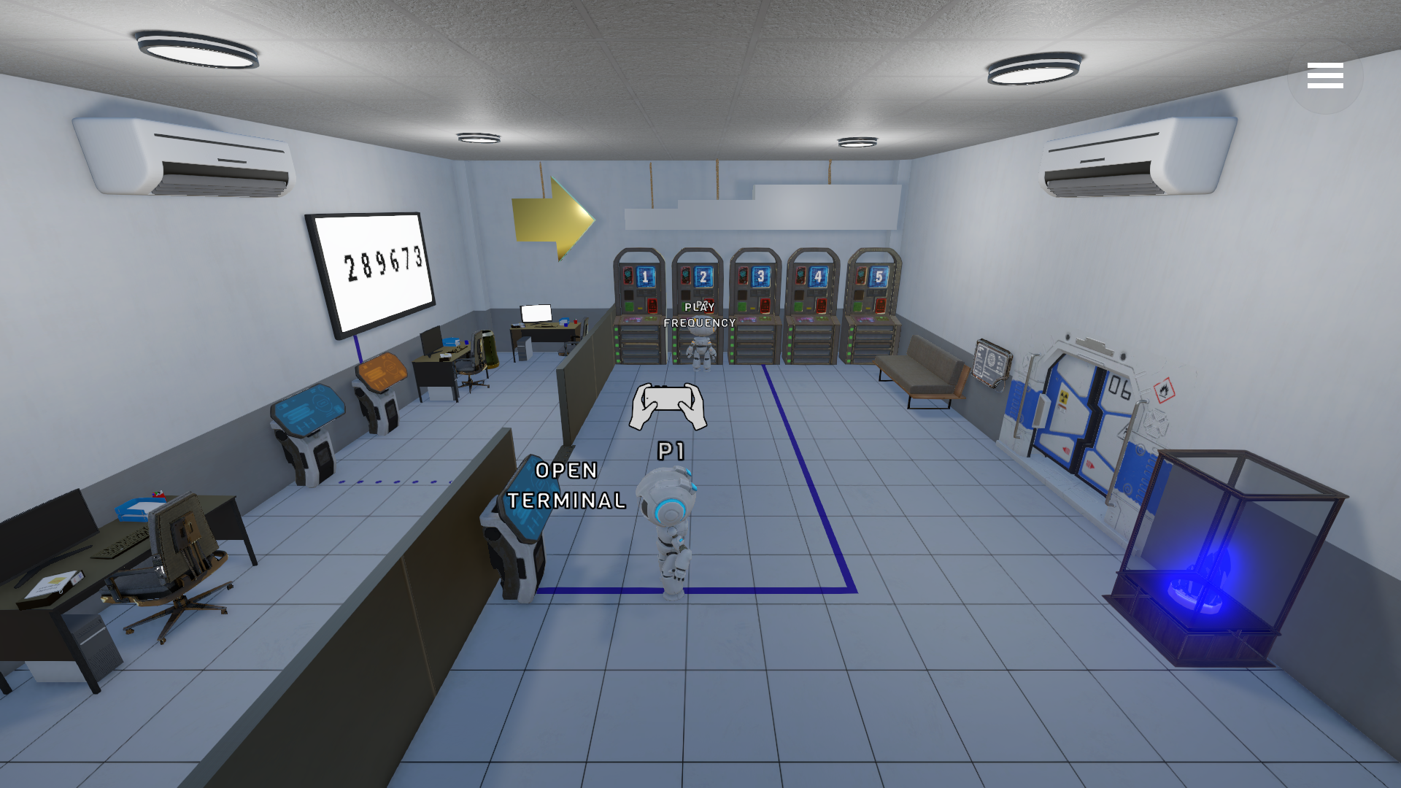
The final puzzle is a sorting challenge. There are 5 machines that play a piano note upon interaction and with the hint above the machines, the players need to understand that the notes must be sorted.
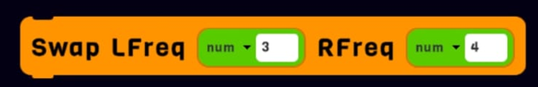
The orange player plays the notes while the blue player swaps them. A puzzle made much easier using teamwork.

Functional Requirements
The following functional requirements are set of features and expectations that we had set to follow while developing the project. All of them are implemented and tested.
The game allows creating lobbies for playing.
The game allows connecting to a host machine.
The game allows placing visual programming blocks.
The game allows displaying tutorial.
The game allows interacting with hints and displaying them on player smartphone.
The game allows the player to control the game through the smartphone.
The game allows interacting with VPL terminals.
The game allows displaying VPL block documentation.
The game allows to collect items (collectables).
The game allows changing settings.

Acceptance Test
Acceptance testing was conducted to verify that the final system met the requirements defined at the beginning of the project. Each major feature, including multiplayer connectivity, puzzle mechanics, player interactions, and the user interface, was tested to ensure it behaved as expected.
# | Module | Tested Functions | Expected Result
1 | Mirror Network | Host Game | Server is online
2 | Unity Application | Display level | Load a level and display it on screen
3 | Mirror Network | Look For Game | Display list of hosts
4 | Mirror Network | Join Game | Successfully join server
5 | Unity Application | Set Nickname | Display a label to enter a username
6 | Mirror Network | Synchronize Players | The player can see how another player behaves in real time
7 | Unity Application | Control Player | Player moves according to inputs sent
8 | Unity Application | Item Interaction | Display a prompt for interaction and perform interact
9 | Unity Application | Interactable | Successfully interacted with world hints and Terminal
10 | Unity Application | Drag VPL Block for Documentation | Successfully display documentation UI for VPL block
11 | Unity Application | Place VPL Blocks | VPL blocks displayed on screen
12 | Unity Application | Edit/Remove VPL Blocks | Change or remove VPL blocks
13 | Mirror Network | Execute Code | Execute code if structure is correct
14 | Unity Application | Open Door | Open door and allow players to escape
15 | Unity Application | Choose Level | Successfully choose a level from a list of levels
16 | Unity Application | Exit Game | Game closed

Challenges and Solutions

Development Process
The development of Code Escape Together began with the design of a cooperative gameplay experience that was both engaging and immersive. Throughout the planning phase, we analyzed existing cooperative games to understand successful gameplay mechanics and puzzle design. While these games served as inspiration, we adapted their ideas to fit the educational objectives and overall vision of our project.
To ensure efficient development, the project was divided into several milestones. The initial focus was on implementing the Visual Programming Language (VPL) system and completing the first game level. Developing the VPL system early allowed us to establish a solid foundation for the game's educational mechanics, making it easier to create additional levels and programming challenges in a consistent and scalable manner.
Once the core gameplay systems and the main levels were completed, development shifted toward enhancing the overall player experience. This included adding gamification elements such as collectible lore items, implementing a journal system to track collected items, refining the user interface, improving visual and audio feedback, and balancing the difficulty of puzzles to create a more intuitive and rewarding experience.
Throughout the project, each new feature was thoroughly tested and refined to ensure proper functionality. Continuous testing allowed us to identify synchronization issues, improve gameplay flow, and optimize the overall performance of the system before the final release.
During development, special attention was given to the multiplayer aspect of the game. Because the project relies on the Mirror networking framework, many gameplay mechanics had to be synchronized across all connected players. Features such as puzzle progression, player interactions, door states, and collectible items required careful implementation to ensure that every client maintained a consistent game state. Several iterations were required to resolve synchronization issues between host and dedicated server configurations.

Development Tools
The project was developed using a combination of software development, game development, and collaboration tools.
- Unity Engine - was used as the primary game engine for creating the game world, implementing gameplay, scenes, and designing the user interface.
- C# - Was used to implement all game logic, including player interactions, puzzle mechanics, networking, and user interface functionality.
- Mirror Networking - Was used to implement multiplayer functionality, allowing players to connect, synchronize states, and collaborate in real time.
- Visual Studio Code - Served as the integrated development environment (IDE) for writing, debugging, and maintaining the project's source code
- Git and GitHub - Were used for version control, enabling us to collaborate efficiently, track changes, and manage different development branches.
- Sketchfab – Was used as the main resource for in game models.

Challenges

Multiplayer Synchronization
One of the biggest challenges was ensuring that all players experienced the same game state in real time. Since the game is cooperative, player interactions, puzzle progress, doors, and collectible items had to remain synchronized across all connected clients.
To solve this challenge, we used the Mirror networking framework. Commands, ClientRPCs, and SyncVars were implemented to ensure that gameplay actions were validated by the server and then synchronized with all connected players. This approach allowed maintaining consistency between clients and prevented desynchronization.

Puzzle Design
Another challenge was designing puzzles that were both educational and enjoyable. The puzzles needed to reinforce programming concepts while encouraging teamwork rather than allowing a single player to solve everything independently.
To address this, each level was designed with mechanics that required cooperation, communication, and logical thinking. The difficulty was adjusted through repeated playtesting until the puzzles were challenging but not frustrating.
Additionally, each level comes with a tutorial about what the level is about so players would be less confused.
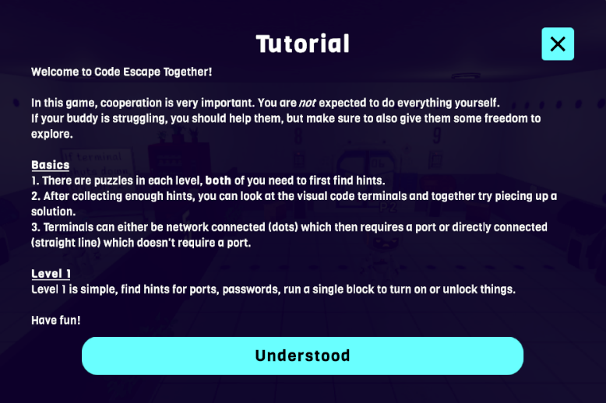

Network Architecture
Supporting both host mode and dedicated server mode introduced additional complexity. Several systems initially worked correctly in host mode but behaved differently when running on a dedicated server.
These issues were resolved by separating server-side game logic from client-side user interface updates and ensuring that only the server was responsible for validating gameplay events.

Performance and Assets
While integrating third-party assets into the project, we encountered performance issues caused by certain models and scene objects.
To overcome this, assets were optimized, unnecessary components were removed, and some models were replaced with lighter alternatives. This improved the overall stability and performance of the game.

User Experience
Creating an intuitive interface for player interactions and puzzle feedback was another challenge.
Several iterations of the user interface were developed, including interaction prompts, journals, collectible displays, and visual indicators. Continuous testing helped improve usability and make gameplay more intuitive.
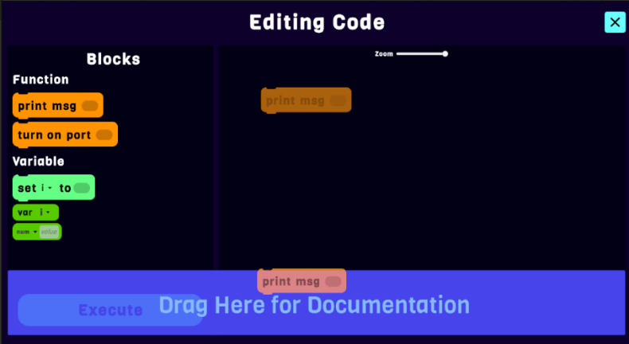
The figure shows the Visual Programming Language (VPL) interface developed for the game. Players solve programming challenges by dragging and arranging visual code blocks within the drop zone. In addition, the interface includes a documentation panel (highlighted in blue) that displays information about the dragged block, allowing players to understand its purpose and functionality without leaving the editor. This feature makes the VPL system more intuitive and beginner friendly.
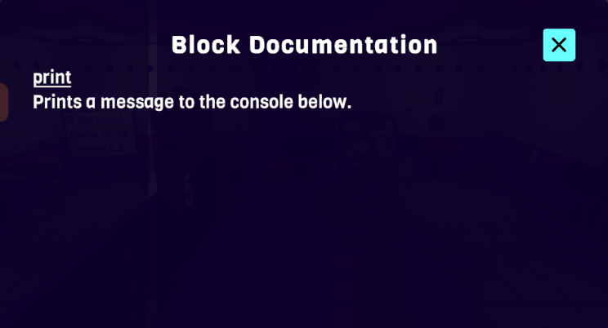
The figure shows the documentation window integrated into the Visual Programming Language (VPL) system. It provides a brief explanation of each programming block, describing its purpose and functionality.

Results and Conclusion
The project successfully achieved its primary objective of creating a cooperative multiplayer educational escape room that teaches programming concepts through interactive gameplay. Players can collaborate in solving programming-based puzzles while experiencing synchronized multiplayer gameplay.
The networking system, puzzle framework, collectible journal, and user interface were successfully integrated into a complete and functional game. Testing demonstrated that players could progress through the levels together while maintaining a consistent game state across connected clients.

Lessons Learned
Overall, we believe the project was developed successfully and met its main objectives. Dividing the project into milestones allowed us to focus on one feature at a time, making the development process more organized and manageable. Implementing the core gameplay mechanics before adding additional content helped establish a stable foundation for the rest of the project.
One of the most valuable lessons we learned was the importance of planning multiplayer systems early in development. Networking introduced challenges that were significantly more complex than those encountered in single-player development. Many gameplay features had to be designed with synchronization in mind from the beginning and implementing them later often required additional modifications.
If we were to develop the project again, we would spend more time on the initial design of the networking architecture before implementing gameplay features. This would likely reduce the amount of refactoring required during development and simplify the implementation of multiplayer interactions.
We would also begin playtesting earlier and more frequently with external users. While the game was tested throughout development, involving additional players at earlier stages could have provided valuable feedback regarding puzzle difficulty, user interface design, and overall gameplay experience.
Finally, if additional time were available, we would expand the project by adding more educational levels, increasing the variety of programming challenges, improving visual effects, and implementing additional game mechanics to further enhance player engagement.

Meeting the Project Goals
Overall, we believe that the project successfully met the goals and success criteria defined during the planning phase.
The primary goal was to develop a cooperative multiplayer educational game that teaches programming concepts through an engaging escape room experience. This objective was achieved by implementing multiple levels containing programming-related puzzles that require teamwork, communication, and logical thinking to solve.
Another important objective was to create a stable multiplayer experience. By using the Mirror networking framework, we successfully synchronized player movement, interactions, puzzle progression, and game events between connected players, allowing them to cooperate in real time.
We also aimed to provide intuitive and immersive user experience. This was achieved through the implementation of interactive user interfaces, collectible lore items, a journal system, visual and audio feedback, and level-specific environments that enhance player engagement.
Through development, testing and iterative improvements helped identify and resolve technical issues, resulting in a stable and functional application. Although there are additional features that could be added in the future, such as new levels, more puzzle types, or advanced educational analytics, the current version fulfills the project's original objectives and provides a complete educational multiplayer experience.

User Manual
Code Escape Together is a fun and engaging 3D cooperative escape room game that softens the entry to programming for newcomers and teenagers by utilizing escape room elements and a visual programming language.

Requirements

PC System Requirements (Server Side)
- Memory: 4 GB
- GPU: DirectX11 or 12 compatible GPU
- CPU: Intel Core i5
- OS: Windows 10 64-bit or Newer
- Storage: 700MB

Mobile System Requirements (Client Side)
- Memory: 4GB
- GPU: Vulkan compatible GPU
- CPU: 1.8+ Ghz Dual-core or Quad-core processor
- OS: Android 8.0 (Oreo)
- Storage: 500MB

Installation

PC Installation
- Download https://github.com/Luffyyy/Capstone-Project/blob/main/Code%20Escape%20Together.exe.
- Run the installer.
- Click Next and then Install.

Mobile Installation
- Download https://github.com/Luffyyy/Capstone-Project/blob/main/Code%20Escape%20Together.apk.
- Click on the APK file downloaded, you may be required to give your browser permission to install unknown apps. Click on “Settings” and then toggle on “Allow permission”. After that, you should be able to install the app.
- Click on “Install” and the app should be installed.

4.3 Hosting and Joining a Server
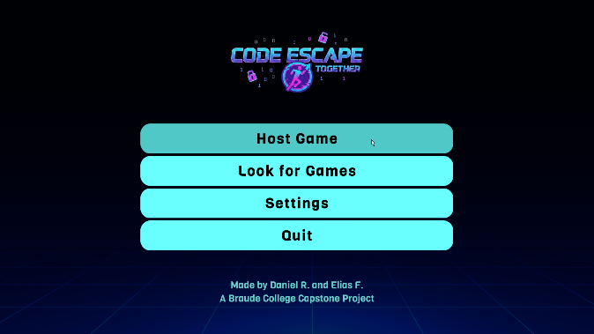
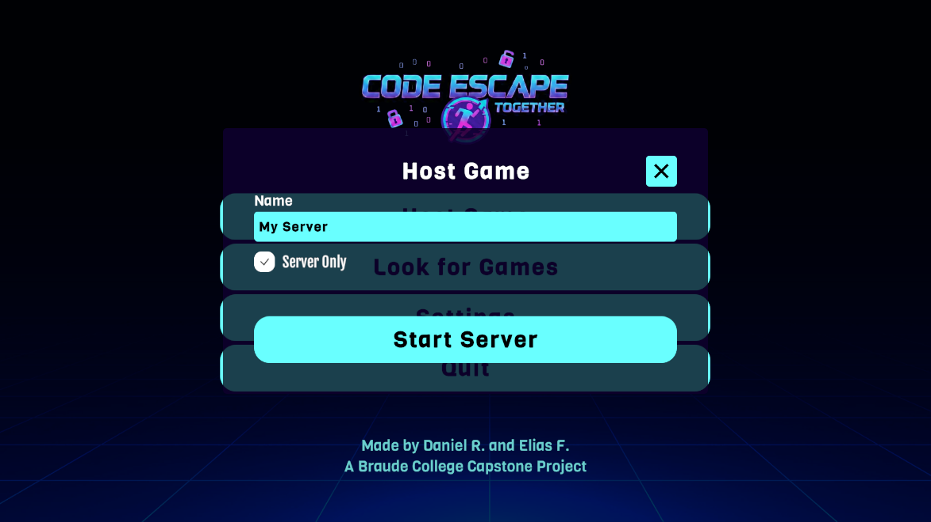
Click on Host Game, you can give the server some name. We’ll keep it as is.
Windows will ask you to open the firewall for the game, this is normal. Click on Allow.
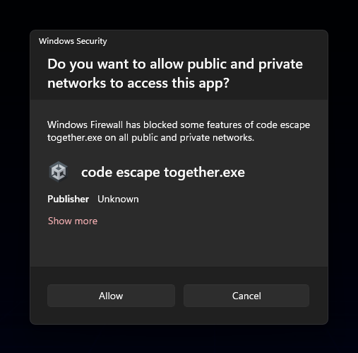
This will open a server for clients to join. Note: you must be connected to the same network. Ensure the network allows for opening of ports.
On two phones, open the game and press the “Look for Games” button. This will show you all servers available in the network. We’ll click on My Server.
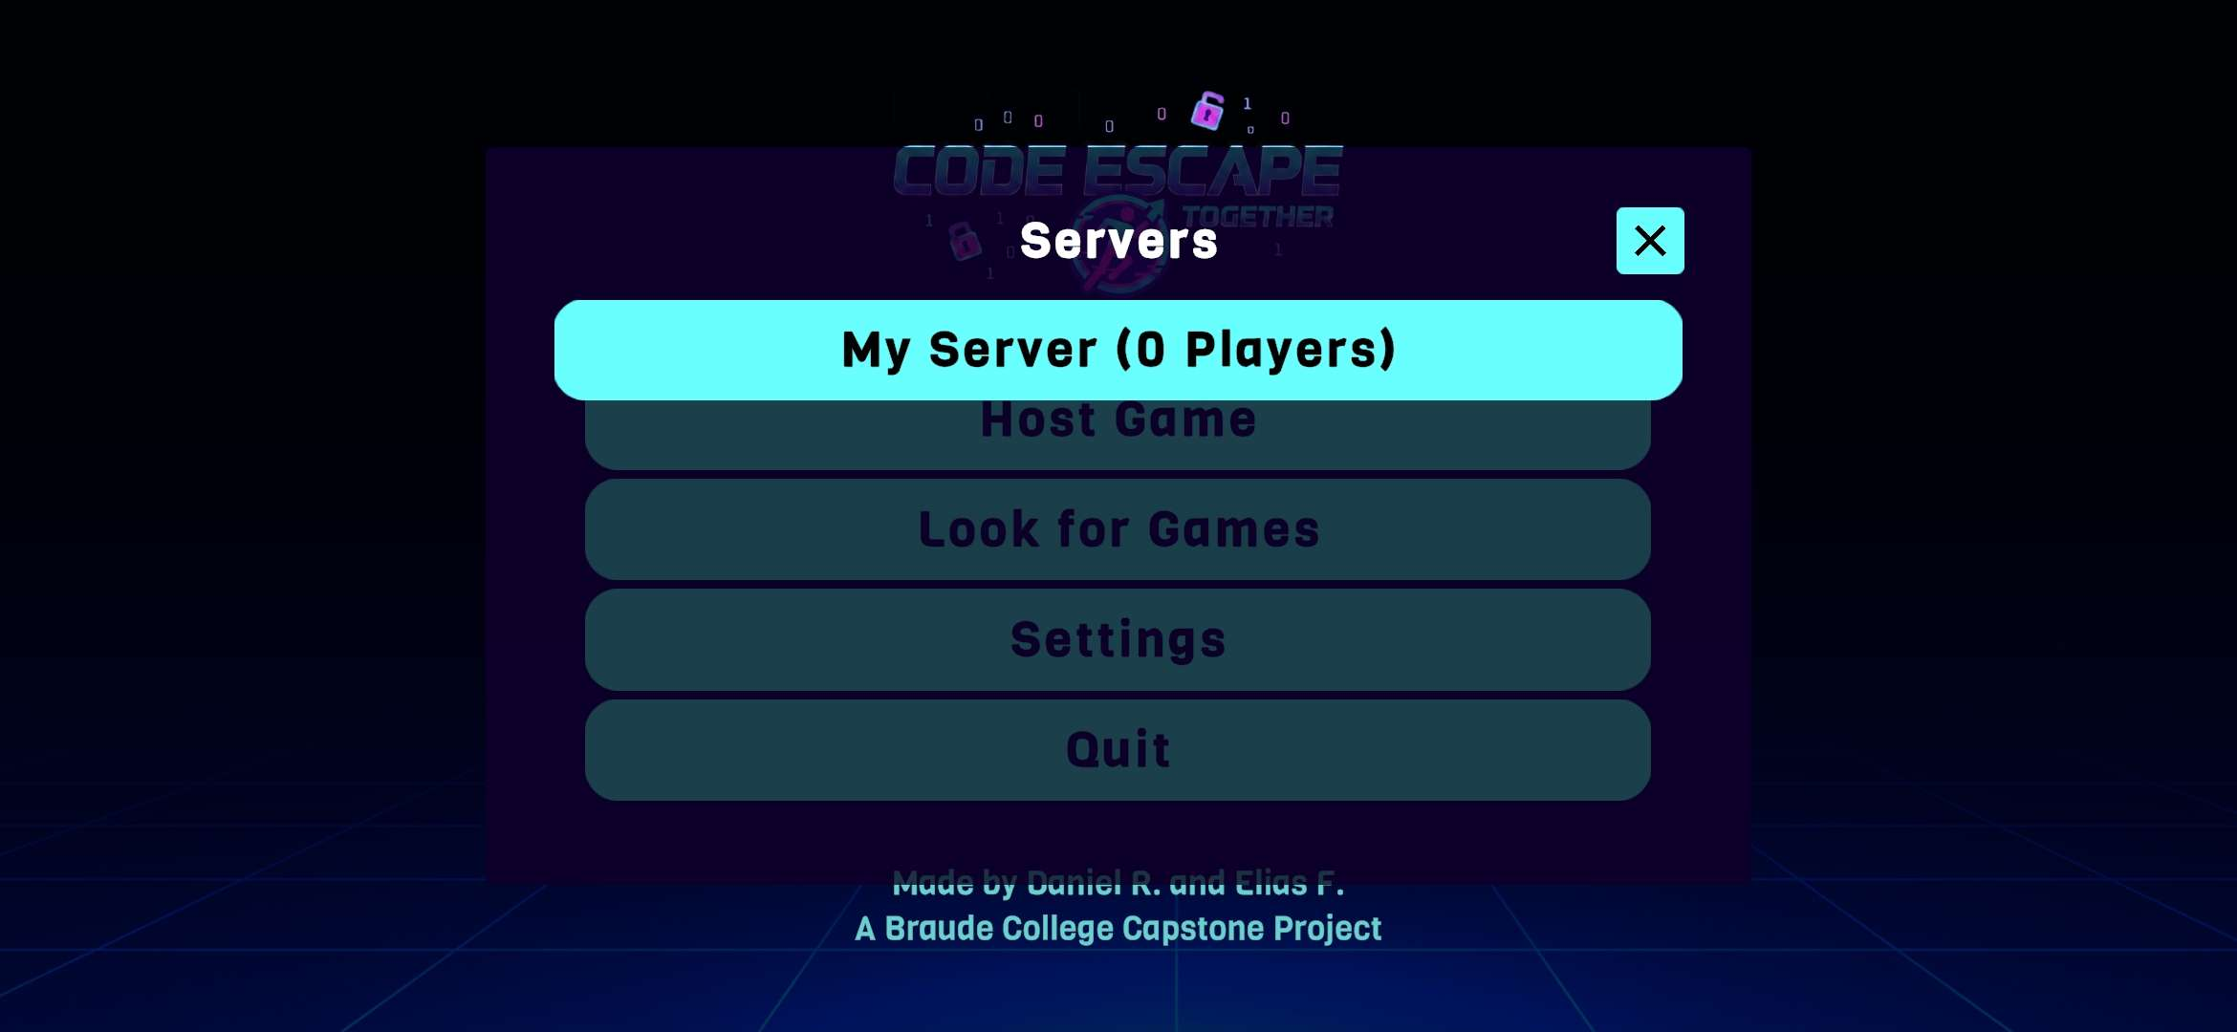

You may change the player’s face expression or username. On the two phones, click on Ready.
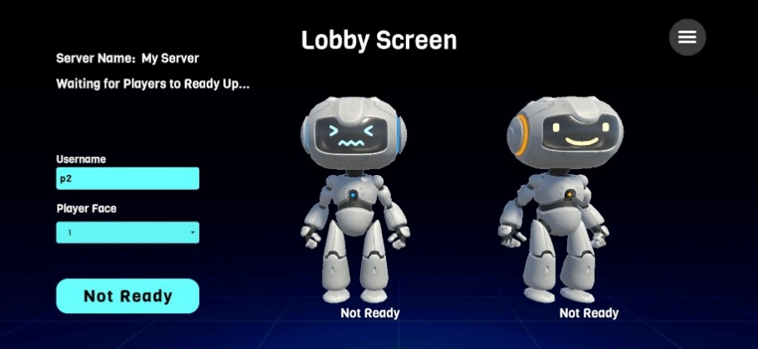

4.4 Game Controls
In regular mode (hosted as server only), the game utilizes the phone as a controller.
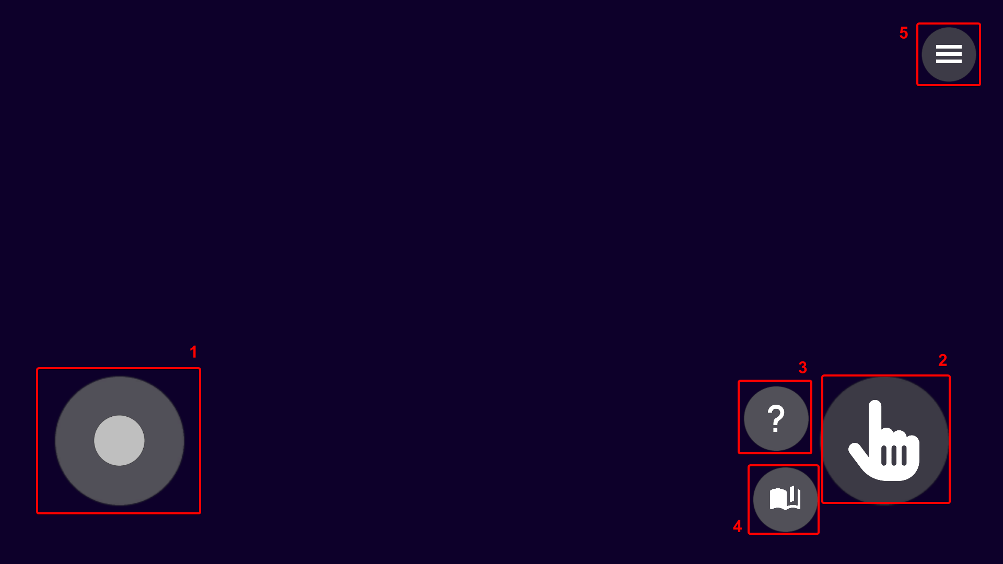
- Movement Joystick
A touch sensitive joystick that moves the player around the map.
- Interact Button
A button that you can press when near a terminal or a hint in the map. All interactions will show small text near the player hinting that you can interact with the object.
- Tutorial Button
Opens the current level’s tutorial if you missed some detail. The tutorial shows up on the server screen for the two players to read while this button opens it on the player’s screen only.
- Journal Button
Opens the journal menu, allow you to see which collectables you’ve found.
- Pause Menu Button
Opens the pause menu which includes resume, settings and quit to menu buttons.

4.5 Gameplay elements
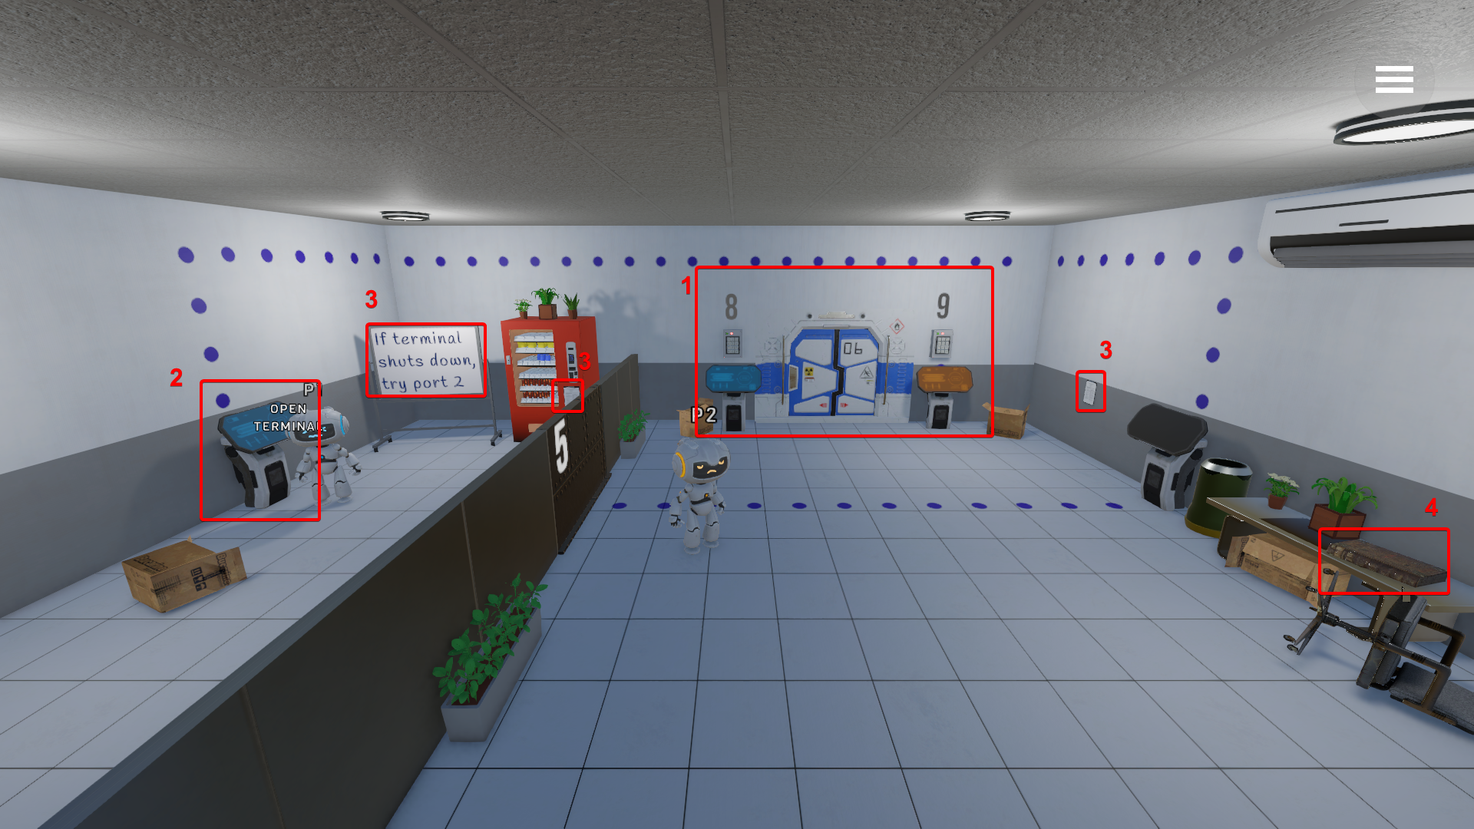

- Escape Rooms
There are four rooms in the game, each room has a door like seen in the picture, the door will open only after solving the main puzzle of the room. Once open, the players may escape and continue to the next room.
- Terminals
Terminals are the method in which the players can interact with the map, pressing interact when near one, will open the “Editing Code” menu, allowing you to manipulate the code that the terminal will run.
Using hints found in the world, the players need to understand how to fill the terminal. For example, if we look at the hint of the whiteboard, we can understand that the needed port for the “turn on” function is 2.
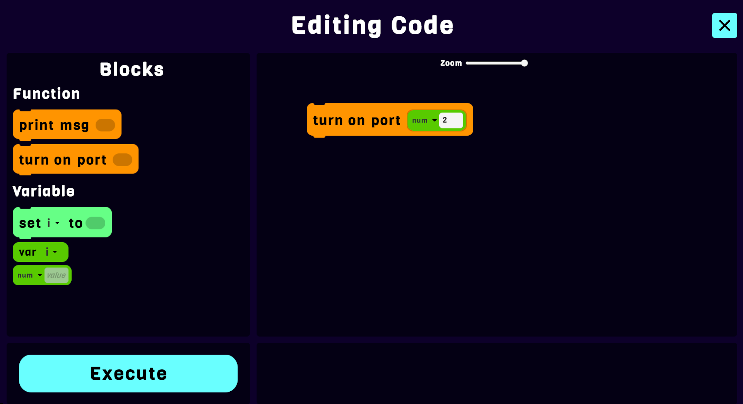
Once the player finds enough hints, they can execute the code. If the code is correct, the level will react to it.
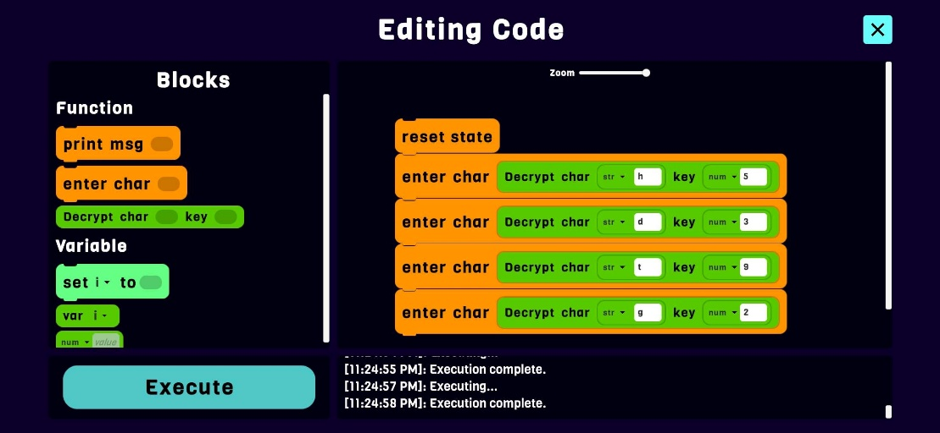
- Hints
Hints come in two ways in the game, world hints and interact hints. World hints are any hints that the map itself gives without doing anything, we can see in the screenshot that the whiteboard gives us a hint.
Interact hints are hints that require the player to go directly to them to interact with them. For example, in the screenshot there are two papers that the player can interact with. If done so, the player will see the following on their phone:
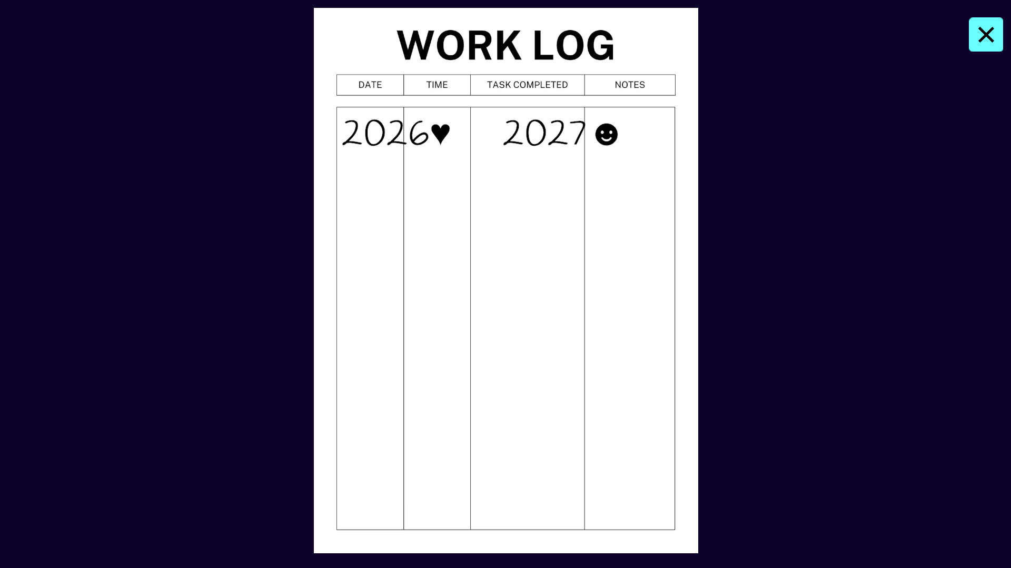
This gives the player a hint that only they see. This enforces teamwork.

- Collectables
To encourage the players to explore more and a form of gamification, the game features collectables that can be picked up. For example, in the screenshot we can see an old book, if a player comes near it, they will pick it up, prompting a message on top of the screen:
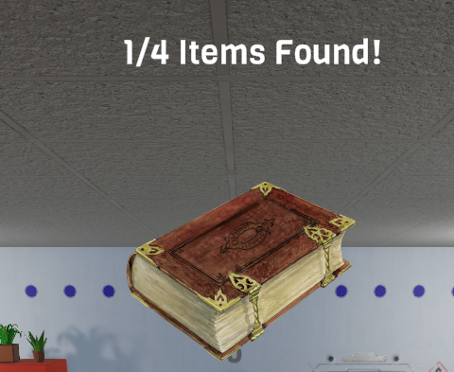
When clicking on the journal button, it will show us the item we found:
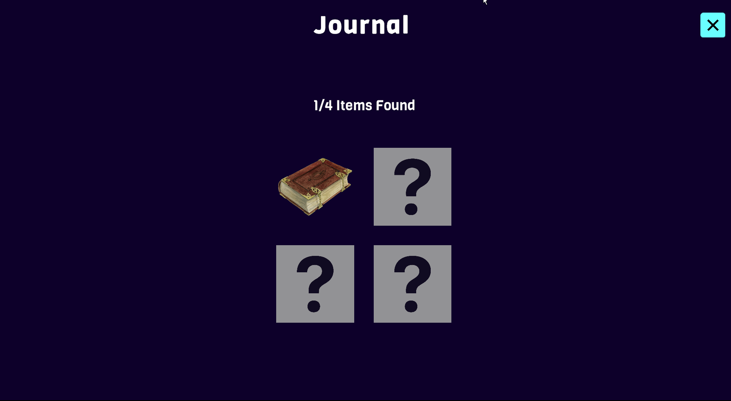
When clicking on any item the players find, it shows you some secret about the game.
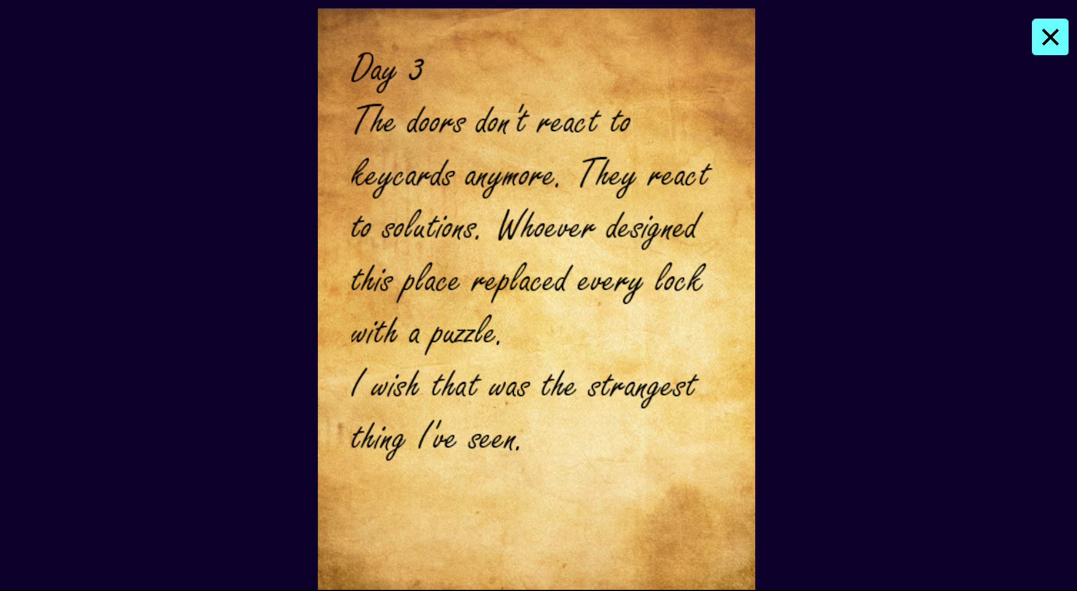

Maintenance Guide
The project is developed on Unity version 6000.2.6f2, therefore the requirements are based on the engine and the game combined.
System Requirements:
- Memory: 8 GB
- GPU: DirectX11 or 12 compatible GPU
- CPU: x64 architecture with SSE2 instruction set
- OS: Windows 10 64-bit or Newer
- Storage: 20GB
For maintenance, we will go over installing Unity and go over some important details about the source code.

Installing Unity Hub
- Navigate to https://unity.com/download, you will be asked to login into your Unity account. Afterwards, Unity will automatically download the correct installer for Unity Hub based on your operating system.
- Open the installer, you will be asked to choose an install location, we will keep it as-is. Click on install.
- Once it’s done, click on finish, it will open Unity Hub.
- You will be asked to log in again, click on sign in and accept the pop up on the browser.

Downloading and Importing the Project
- Git clone the project using either git or some git client.
- In Unity Hub, click on “Add” and then “Add project from disk”, navigate to the location of the project and click open on the folder “Project”.
- If you don’t have Unity 6000.2.6f2, Unity will prompt you about it and ask you to download the version. You may upgrade it yourself to a future version, but it might break some things. Click on “Install Version 6000.2.6f2”. After that, toggle Android Build Support (note: if you have MacOS, you may install iOS build support too).
- Click continue, accept terms and conditions and click on install, this will start the download and installation of the right Unity version.
- Once done, you can click on the project to open the project in Unity Engine.

Structure Walkthrough
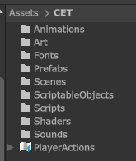
The project code and files are all stored in Assets/CET, the rest are addons.
Root Structure
- Animations – Includes animations for GUI and game objects.
- Art – Includes art of the game, models, textures and materials.
- Fonts – Includes the fonts used in the game.
- Prefabs – Includes the various prefabs such as the terminal.
- Scenes – Includes the scenes of the levels, lobby, credits and the online scene (shared scene across all levels).
- ScriptableObjects – Data objects such as VPL blocks defined in the game.
- Scripts – The scripts of the game, will be expanded below.
- Shaders – Custom shaders written for the game.
- Sounds – The sounds of the game such as the music or piano sounds.
Code Structure
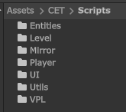
The source code is split into 7 main folders:
- Entities – Anything that is interactable in the level.
- Level – Utility components such as the portal for next level or the start position.
- Mirror – Scripts relating to the Mirror library, mostly network code.
- UI – Scripts for UI including both menu code and HUD (Heads-up display) code.
- Utils – General utilities.
- VPL – Scripts for the whole visual programming language system.
Main Classes
- VPL/VPLZone
The heart of the project. The class oversees the whole visual programming language of the game. It uses VPLStore to know what blocks it has which is a ScriptableObject that holds instances of BlockDefinition.
- VPL/BlockDefinition
Base class for defining each block type. In general, there are the following block types: base, function, expression function (able to return a value), operator and prefab. There’s also an unimplemented event type which was planned to be used for room specific events.
- VPL/BaseBlock
The base class for the logic of each block. If you need to make a new block type, you will likely need to look at this class and possibly the classes that inherit it.
- Player/PlayerController
A controller class for controlling the player, the controls are handled on the client side and synched via Mirror. It handles more things such as interaction with the world (server sided), phone focus icon above the player. It also handles the main player input (unity component for input listening) which is used to also open menus like the journal or tutorial menu.
- UI/HUDManager
A manager class for handling the HUDs in the game. Things such as the player control icons and the pause menu are enabled via this class.
- UI/MenuManager
A manager class or handling the menus and dialogs in the game. It handles each menu in a stack so you can return to the last menu you were in when you close the current.
- Entities/Entity
Base class for all entities. It only contains a property for port. If the object doesn’t need one, you keep it as -1.
- Entities/Activatable
Entities that can be turned on or off. If the entity has an emission renderer set, it handles turning the emission color on or off based on whether the entity is turned on. A player index (0 or 1) may be also set to only allow a specific player to access it. Keep it as -1 to allow all players to access it.
- Entities/Interactable
Base class for interactable objects. It inherits the activatable class. You can override CmdInteract to decide what happens on the server when a player interacts with it and TargetInteract which executes on the specific player’s side.

Running in Editor
Since building takes long, it’s a good idea to first test the game in play mode.
- Open the main menu scene found in Assets/CET/Scenes/MainMenuScene.
- Click on the play button on the top.


Building
As mentioned before, the game is supposed to run on a computer (Windows usually) and phones (Android, however iOS steps are similar if you own a MacOS powered computer)
- Click on File and then Build Profiles
- Click on “Build” and choose where to save the project. If you are building for Windows, you’re choosing the folder where Unity will place the built files of the game. If you’re building for Android, you’re choosing where it places the APK file.
- Switch to the other platform by clicking on the platform you’re interested in and then “Switch Platform”.

Notes
- Mirror runs the server locally at port 7777. It’s possible to change the port if you go to the MainMenuScene and then change the settings in the NetworkManager.
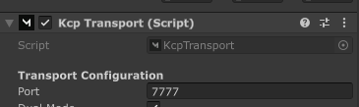
- The game utilizes a custom network manager built by us to allow for switching levels. If you wish to add new levels, you need to add new levels to the “Additive Scenes” property in the network manager inspector.
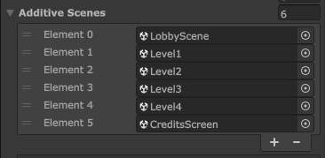
- To test multiplayer on the same device, you can utilize ParrelSync, click on ParrelSync then on Clones Manager and then “Create new clone”. This will create a copy of the engine so make sure you have the space for it.

References
- Huang, B., & Hew, K. F. (2015, November). Do points, badges and leaderboard increase learning and activity: A quasi-experiment on the effects of gamification. In International Conference on Computers in Education.
- Giakalaras, M. M. (2016). Gamification and storytelling. Univ. Aegean, 8, 1-7.
- Veldkamp, A., Van De Grint, L., Knippels, M. C. P., & Van Joolingen, W. R. (2020). Escape education: A systematic review on escape rooms in education. Educational Research Review, 31, 100364.
- Wanglang, C., Sraubon, K., & Piriyasurawong, P. (2024). Combining Game-Based Learning with Design Thinking Using Block-Based Programming to Enhance Computational Thinking and Creative Game for Primary Students. Higher Education Studies, 14(2), 137-147.
- Gordillo, A., & López-Fernández, D. (2024). Are educational escape rooms more effective than traditional lectures for teaching software engineering? A randomized controlled trial. IEEE transactions on education, 67(5), 660-668.
- Videnovik, M., & Trajkovik, V. (2018). Using Scottie Go! as Game Based Learning Tool for Computational Thinking Course. In ICERI2018 Proceedings (pp. 1337-1344). IATED.
- Humble, N., Mozelius, P., & Sällvin, L. (2021, September). You can’t escape learning, but maybe you can get out of the room!-Game-based learning for programming education. In Proceedings of the European Conference on Games-based Learning (pp. 361-369).
- Wynn, A., Wang, J., Han, R., & Hsu, T. C. (2023, September). Multiplayer serious games supporting programming learning. In European Conference on Games Based Learning (Vol. 17, No. 1, pp. 721-729). Academic Conferences International Limited.
- Escape Simulator - Wikipedia. https://en.wikipedia.org/wiki/Escape_Simulator

